1. Affiliate Marketing

payment-types: if you refer someone who stays a customer and buys often things

2. Real-Estate → he outsourced everything! And they give him an excel sheet like this:
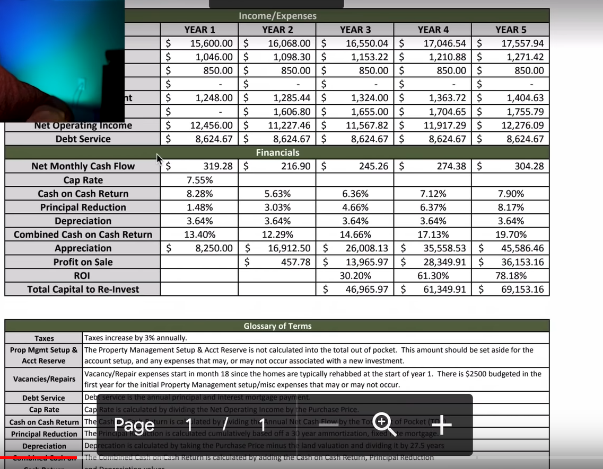

3. Digital Courses, also Blogs

3b. YouTube Ad Revenue

=> Advertisers before youtube-videos spend a LOT OF MONEY on Health and Wealth, per 1000 clicks 40-50$! For ex. Lego channels on 1000 Clicks make only 2-3$

4.Launching a Software-Company!
A plugin which is made for affiliate marketing!

Hes Planning to do:
5. Online Service Arbitrage!
=> er vermittelt gute Leute (z.B. Entwickler, Designer etc.) an andere Leute!

